5.1 Introductions to Estimation (pg1)

Sampling dist. of mean y-bar

* Sample is random, normal
  + Large sample (n >=30, then CLT applies)
* Normal dist.
* Std. Dev of sample mean:
* Center: true value of pop. Mean 

Sampling dis. Of sample proportion p-hat

* Random, lage sample (np >= 10 and n(1-p) >= 10
* Normal dist.
* Std. Dev of sample prop: 

5.2 Margin of Error (pg3)

* Multiplier x Std. Dev
* Proportion:
* Standard Normal Dist
* Use Stattrek to find multipliers
* Mean:

5.3 t-distribution (pg6)

* Degrees of Freedom explanation pg7
* Stattrek.com
* For a t dist w/ v =12, find P(t <= -1.53)

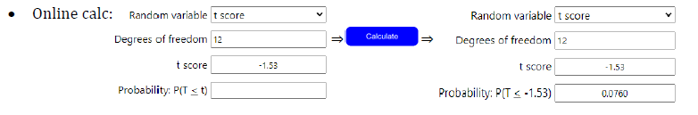

* For a t dist w/ v =7, what is the multiplier for 90% confidence?

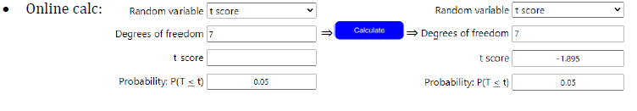

5.4 Confidence Interval (pg10)

* Statistic +- MoE

CI fo Population Proportion

* Std. Normal Dist, Large sample (np >=10 and n(1-p)>=10)

CI for Pop. Mean

* Random Sample, Population follows normal unless large sample (>30)
* T distribution w/df = n -1
* “If we repeatedly took random samples of size “n” and calculated a 95% CI for each, 95% of the resulting CI’s would contain the parameter”
* Large sample sizes = smaller MoE
* MoE only accounts for random sampling variability, not issues in data collection
* Confidence Interval is about the parameter, not about the stat or the individuals